1.我在学习这门课的过程中存在的问题主要是应用所学有困难。在面对新问题的时候不太会举一反三，习惯寻求帮助。

2.（1）使用R可以在进行重复流程时节省时间

（2）R擅长大数据处理

（3）R具有庞大数量的包

3. help(numeric)

Num = numeric(4);



4. User_ID = 9527;

mode(User_ID);

User_ID = as.character(User_ID);

mode(User_ID);

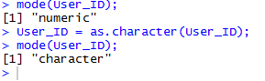

5. age = 17;

if(age < 18){

is_adult = FALSE;

}else{

is_adult = TRUE;

}



6. a

groups = 6;

members = 4;

trees = 360;

avg = trees/(groups*members)



#b

speed = 18;

length_car = 18;

length_tunnel = 324;

time = (length_tunnel+2*length_car)/speed



#c

woodpecker_weekly = 4515;

tit_weekly = 1155;

excess_daily = woodpecker_weekly/7 - tit_weekly/7



#d

length = 12;

width = 8;

deltaarea = (length+2)*(width+2) - length*width



7.

result = seq(2,15,3)



8.

names = c("zhangsan","lisi","wangwu");

height = c(165,175,170);





9.

user.data = data.frame(names,height);

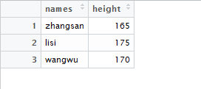

10.

names = c(names,"xiaomiing");

height = c(height,185);

user.data = data.frame(names,height);

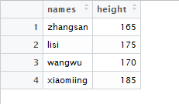

11.

for(i in 1:4){

if(height[i] >= 170){

print(names[i]);

}

}

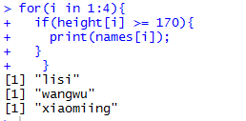

12.

weight = c(55,65,70,80);

user.data <- cbind(user.data,weight)

